

AUTOMATED EXAM SEATING SYSTEM: INTELLIGENT SEAT ALLOCATION TO PREVENT SAME-BRANCH CLUSTERING
A CAPSTONE PROJECT REPORT
A Capstone Project Report submitted in partial fulfilment of the requirements
for the Course of
CSA1008-SOFTWARE ENGINEERING
to the award of the degree of
BACHELOR OF TECHNOOGY
IN
INFORMATION TECHNOLOGY
Submitted by
JAGAN G
PRIYAN A
PUSHPARAJ G
AJAY KUMAR
MOHAN KRISHNA BALAJI

Under the Supervision of
DR. K.C.SHARMILI
SIMATS ENGINEERING
Saveetha Institute of Medical and Technical Sciences
Chennai-602105
SEPTEMBER 2026


SIMATS ENGINEERING
Saveetha Institute of Medical and Technical Sciences
Chennai-602105
BONAFIDE CERTIFICATE
This is to certify that the Capstone Project entitled “AUTOMATED EXAM SEATING SYSTEM: INTELLIGENT SEAT ALLOCATION TO PREVENT SAME-BRANCHCLUSTERING” has been carried out by Jagan G, Priyan A, Pushparaj G, Ajay Kumar, and Mohan Krishna Balaji under the supervision of Dr. .K.C. sharmiliand is submitted in partial fulfilment of the requirements for the B.Tech Information Technology program at Saveetha Institute of Medical and Technical Sciences, Chennai.

COURSE COORDINATOR
Dr K Anitha Davamani
COURSE FACULTY
Dr. K.C Sharmili
Assisant Professor
Department Of Computer Science
SIMATS Engineering,
Chennai – 602105.
Professor
Department of Nxt-gen,
SIMATS Engineering,
Chennai – 602105.


SIMATS ENGINEERING
Saveetha Institute of Medical and Technical Sciences
Chennai-602105
DECLARATION
We, Jagan G, Priyan A, Pushparaj G, Ajay Kumar, and Mohan Krishna Balaji of the Department of Information Technology, SIMATS Engineering, Saveetha Institute of Medical and Technical Sciences, Chennai, hereby declare that the Capstone Project Work entitled “AUTOMATED EXAM SEATING SYSTEM: INTELLIGENT SEAT ALLOCATION TO PREVENT SAME-BRANCH CLUSTERING” is the result of our own bonafide efforts. To the best of our knowledge, the work presented herein is original and has been carried out in accordance with engineering ethics and academic integrity. All sources, references, data, and external resources used in the project have been appropriately acknowledged. We confirm that the results and analysis presented in this report have not been fabricated or falsified and that applicable ethical, academic, institutional, and professional requirements have been followed.
Place: Chennai
Date:

Signature of the Students with Names
Jagan G
Priyan A
Pushparaj G
Ajay Kumar
Mohan Krishna Balaji

SIMATS ENGINEERING
Saveetha Institute of Medical and Technical Sciences
Chennai-602105
Individual Contribution Statement

Student / Reg. No. | Specific Responsibilities | Design & Development Contribution | Testing & Analysis Contribution | Report Contribution | Approx. %
Jagan G | MODULE 2: Automated Examination Seat Allocation System | Developed branch-aware seat placement. | Tested clustering reduction. | Sections 3.3 and 4.2 | 20%
Priyan A | MODULE 4: Student Information Management System | Prepared student and seat data. | Validated input records. | Sections 1.1–1.7 and Module 1 | 20%
Pushparaj G | MODULE 3: Report Generation and Export System | Prepared seating charts. | Checked visual output. | Sections 3.3 and 4.4 | 20%
Ajay Kumar | MODULE 1: Exam Hall & Room Management System | Prepared test cases. | Verified assignment uniqueness. | Sections 4.3–4.4 | 20%
Mohan Krishna Balaji | MODULE 5: Seat Conflict Detection & Validation System | Documented project requirements. | Reviewed results against objectives. | Sections 2 and 4.6 | 20%
Total |  |  |  |  | 100%

ABSTRACT
University examinations with multiple branches and large student groups require a seating plan that is fair, conflict-aware, easy to verify, and practical for invigilators. Manual or sequential allocation can place students from the same branch next to one another, producing visible clustering and making the seating pattern less balanced.This project, titled “Automated Exam Seating System: Intelligent Seat Allocation to Prevent Same-Branch Clustering,” develops an intelligent examination seating workflow using five integrated modules. Module 1 manages validated student information; Module 2 performs automated branch-aware seat allocation; Module 3 generates seating reports and exports; Module 4 manages examination halls, rooms, capacities, and seat coordinates; and Module 5 detects conflicts and validates the final allocation. The system treats each student and seat as a constrained assignment and uses horizontal and vertical adjacency to measure same-branch clustering. The final seating arrangement is released only after uniqueness, capacity, blocked-seat, and clustering checks are completed.The proposed approach is implemented in Python using Pandas for structured data handling and Matplotlib for visualisation. A sample 5 × 6 examination hall containing 30 students from CSE, IT, and ECE branches is used for verification. The allocation objective is expressed as minimising the number of horizontally or vertically adjacent seats occupied by students from the same branch. In the sample case, sequential allocation produces 35 same-branch adjacent pairs, a random allocation produces 18, while the intelligent allocation produces The results show that the proposed method can generate a balanced seating arrangement while maintaining one-student-per-seat allocation and preserving room capacity. The system is intended as a transparent academic prototype that supports examination administrators by reducing manual effort, preventing avoidable branch clustering, and providing an auditable seating plan. It can be extended with additional constraints such as subject combination, accessibility, special seating requirements, room availability, and larger examination halls.
Keywords: Automated Exam Seating, Seat Allocation, Same-Branch Clustering, Constraint Satisfaction, Optimisation, Examination Management, Intelligent Seating.

TABLE OF CONTENTS
1 |  | ABSTRACT | 5
2 | 1.2 | TABLE OF CONTENTS | 6
3 | 1.3 | LIST OF FIGURES | 8
4 | 1.4 | LIST OF TABLES | 9
5 | 1.5 | LIST OF ABBREVIATIONS / SYMBOLS | 10
6 | CHAPTER 1 | INTRODUCTION AND ENGINEERING PROBLEM | 11
6.1 | 1.1 | Background | 11
6.2 | 1.2 | Need for the Project | 12
6.3 | 1.3 | Problem Statement | 12
6.4 | 1.4 | Project Aim | 12
6.5 | 1.5 | Project Objectives | 13
6.6 | 1.6 | Scope | 13
6.7 | 1.7 | Expected Engineering Outcome | 13
7 | CHAPTER 2 | LITERATURE REVIEW AND EXISTING SOLUTIONS | 14
7.1 | 2.1 | Review Method | 14
7.2 | 2.2 | Review of Existing Work | 14
7.3 | 2.3 | Comparative Analysis | 14
7.4 | 2.4 | Research / Engineering Gap | 15
7.5 | 2.5 | Proposed Contribution | 15
8 | CHAPTER 3 | ENGINEERING DESIGN & TRADE-OFFS, SUSTAINABILITY, ETHICS, SAFETY, RISK & SECURITY | 16
8.1 | 3.1 | Requirements | 16
8.1.1 | — | Stakeholder / User Requirements | 16
8.1.2 | — | Functional & Non-Functional Requirements | 16
8.2 | 3.2 | Constraints & Applicable Standards | 17
8.3 | 3.3 | Design Specifications | 17
8.4 | 3.4 | Alternative Solutions & Evaluation | 17
8.5 | 3.5 | Selected Design & Detailed Design | 18
8.5.1 | 3.5.6 | Module 1: Student Information Management System | 18
8.5.2 | 3.5.7 | Module 2: Automated Examination Seat Allocation System | 18
8.5.3 | 3.5.8 | Module 3: Report Generation and Export System | 18
8.5.4 | 3.5.9 | Module 4: Exam Hall & Room Management System | 18
8.5.5 | 3.5.10 | Module 5: Seat Conflict Detection & Validation System | 18
8.6 | 3.6 | Trade-off Analysis | 19
8.7 | 3.7 | Sustainability, Ethics, Safety, Risk & Security | 19
8.7.1 | 3.7.1 | Risk Register | 20
9 | CHAPTER 4 | IMPLEMENTATION, TESTING & RESULTS, PROJECT MANAGEMENT | 21
9.1 | 4.1 | Development Approach & Resources | 21
9.2 | 4.2 | Software Implementation & Modern Tools Used | 21
9.2.1 | 4.2.1 | Module 1 – Student Information Management System (Priyan A) | 21
9.2.2 | 4.2.3 | Module 2 – Automated Examination Seat Allocation System (Jagan G) | 21
9.2.3 | 4.2.4 | Module 3 – Report Generation and Export System (Pushparaj G) | 21
9.2.4 | 4.2.5 | Module 4 – Exam Hall & Room Management System (Ajay Kumar) | 21
9.2.5 | 4.2.6 | Module 5 – Seat Conflict Detection & Validation System (Mohan Krishna Balaji) | 21
9.3 | 4. | Test Plan & Verification | 22
9.4 | 4.4 | Results | 22
9.5 | 4.5 | Data Analysis & Engineering Judgment | 23
9.6 | 4.6 | Comparison with Existing Solutions & Achievement of Objectives | 23
9.7 | 4.7 | Strengths & Limitations | 24
9.8 | 4.8 | Project Planning, Roles & Budget | 24
10 | CHAPTER 5 | CONCLUSION, FUTURE WORK AND REFLECTION | 25
10.1 | 5.1 | Conclusion | 25
10.2 | 5.2 | Future Work | 25
10.3 | 5.3 | Professional Learning & Individual Reflection | 25
10.3.1 | 5.3.1 | Individual Reflection – Priyan A (192421321) | 25
10.3.2 | 5.3.2 | Individual Reflection – Jagan G (192421039) | 26
10.3.3 | 5.3.3 | Team Reflection – Validation and Integration | 26
11 | 5.3.4 | REFERENCES | 27
12 | 5.3.5 | APPENDICES | 28
13 | 5.3.6 | CAPSTONE PROJECT OUTCOME MAPPING SHEET | 29
13 | 5.3.7 | CAPSTONE PROJECT OUTCOME MAPPING SHEET | 29

LIST OF FIGURES
Figure No. | Figure Name | Page No.
1 | Automated Exam Seating Layout Showing Branch-Aware Allocation | 22
2 | Comparison of Same-Branch Clustering for Baseline and Proposed Allocation | 23

LIST OF TABLES
Table No. | Table Name | Page No.
2.1 | Comparative Analysis of Existing Seating Allocation Approaches | 14
4.1 | Seating Allocation Results Compared with Baseline Approaches | 23

LIST OF ABBREVIATIONS / SYMBOLS
Symbol | Description | Unit
ID | Student identification number | –
CSE | Computer Science and Engineering | –
IT | Information Technology | –
ECE | Electronics and Communication Engineering | –
Seat | Available examination position | –
C | Same-branch clustering score | count
E | Number of adjacent seat pairs | count
Adj | Seat-adjacency relation | –
CSV | Comma-Separated Values | –
UI | User Interface | –

CHAPTER 1
INTRODUCTION AND ENGINEERING PROBLEM

1.1 Background
University examinations commonly involve students from several branches writing the same examination in multiple rooms. A seating plan must distribute students across the available seats while respecting room capacity, student eligibility, examination rules, and practical invigilation requirements. When students are seated in registration order or branch order, long runs of the same branch can occur. Such clustering is undesirable when the institution wants a visibly mixed seating pattern and a simple mechanism for reducing branch concentration.
The seating problem can be represented as a constrained allocation problem. Each student is mapped to exactly one seat, each seat is assigned to at most one student, and additional rules can be represented as hard constraints. A soft objective can then minimise the number of adjacent seat pairs belonging to the same branch. This formulation turns a repetitive manual task into a systematic engineering workflow that can be implemented, tested, and audited.

1.2 Need for the Project
Manual seating preparation becomes time-consuming when student lists, branches, rooms, and seat capacities change. Simple alphabetical or register-number ordering is easy to prepare but may create same-branch clusters. Repeatedly editing such lists also increases the chance of duplicate students, missing students, invalid seat numbers, or inconsistent room capacities.
There is therefore a practical need for an automated method that accepts structured examination data, applies mandatory constraints first, then improves the allocation according to a clearly defined clustering objective. The method should remain simple enough for staff to understand and verify rather than behaving as an opaque black box.

1.3 Problem Statement
Given a list of students with branch information and a set of available examination seats, the system must produce a valid one-student-per-seat allocation while minimising adjacent seats occupied by students from the same branch. The problem combines hard constraints, such as seat capacity and unique assignment, with a soft optimisation goal, namely reduction of same-branch adjacency. The system should also provide a final seating chart and measurable evidence showing whether clustering has been reduced.

1.4 Project Aim
To design, implement, and validate an automated examination seating system that intelligently allocates students to seats while preventing same-branch clustering and producing a clear, verifiable seating arrangement.

1.5 Project Objectives
● To prepare and validate student, branch, examination-room, and seat-capacity data before allocation.
● To model one-student-per-seat and room-capacity rules as hard constraints.
●To define a measurable same-branch clustering score using horizontal and vertical seat adjacency.
● To implement an intelligent allocation procedure that reduces the clustering score through branch-aware placement and seat swaps.
● To generate a final seating chart that is easy for invigilators and students to interpret.
● To test the system using a sample examination dataset and compare it with simple manual and random allocation approaches.

1.6 Scope
Included:
● Student-list validation, branch identification, room capacity checking, and seat-map preparation.
● Automated allocation of students to available seats while maintaining one-student-per-seat assignment.
● Calculation and reduction of same-branch adjacent seat pairs, followed by generation of a final seating chart and summary report.

Excluded:
● Full university timetable generation, subject scheduling, and examination-date planning.
● Biometric attendance, facial recognition, or continuous student surveillance.
● Automatic handling of every institution-specific special-case rule without configuration.
Assumptions and Boundary Conditions:
● Each student has a valid branch label and belongs to the examination being allocated.
● The room layout, seat count, and blocked/accessible seats are known before allocation.
● Horizontal and vertical neighbouring seats are treated as adjacent for the clustering metric.

1.7 Expected Engineering Outcome
The expected outcome is a validated Python-based prototype that accepts structured examination data, creates a branch-aware seating arrangement, reports the same-branch clustering score, and produces a final seating chart. For the sample case, the system is expected to preserve all 30 student assignments while reducing the clustering score compared with sequential and random baselines.

CHAPTER 2
LITERATURE REVIEW AND EXISTING SOLUTIONS

2.1 Review Method
Relevant work was reviewed from examination timetabling and educational scheduling literature, graph-colouring and constraint-satisfaction concepts, and practical approaches to automated allocation. The review focused on methods that can represent hard constraints separately from soft objectives and that can provide measurable evidence of allocation quality.

2.2 Review of Existing Work
Examination timetabling research treats scheduling as a constraint-rich optimisation problem in which feasibility must be maintained while one or more soft objectives are improved. Similar ideas apply to seating: students, seats, rooms, and examination rules form the input entities, while adjacency and branch-mixing preferences define quality.
Graph-based approaches are useful because seats can be represented as vertices and neighbouring seats as edges. A same-branch conflict occurs when the two endpoints of an edge contain students from the same branch. Greedy assignment, local search, swap-based improvement, graph colouring, and metaheuristic approaches can all be used to reduce such conflicts. For a capstone prototype, a transparent greedy-plus-local-improvement strategy offers a useful balance between implementation effort and explainability.

2.3 Comparative Analysis
Existing Approach | Advantages | Limitations | Relevance to Proposed Work
Sequential registration-order allocation | Very simple and fast; easy to generate | Can create long same-branch runs; no explicit quality metric | Used as the baseline to measure clustering reduction
Random allocation | Simple diversification; low implementation effort | Quality is unpredictable and may violate additional practical preferences | Used as a second baseline for comparison
Full optimisation / constraint solver | Can model many hard and soft constraints and search globally | More modelling effort; may be excessive for a small academic prototype | Considered as a future extension for larger deployments
Branch-aware greedy + local swaps | Transparent, lightweight, directly minimises the defined clustering score | May not guarantee global optimum for every dataset | Selected as the core method of this project

2.4 Research / Engineering Gap
Existing scheduling and optimisation techniques can solve complex examination problems, but a smaller academic implementation is still useful when administrators need a transparent seating-specific tool. A simple sequential list does not actively measure clustering, while a fully general optimisation system can be difficult to configure and explain. The engineering gap addressed here is a lightweight method that explicitly measures same-branch adjacency, improves the allocation, and reports the result in a form that can be manually checked.

2.5 Proposed Contribution
This project contributes a modular seating-allocation workflow split into Exam Data Preparation and Constraint Modelling, followed by Intelligent Seat Allocation and Validation. The proposed method combines a branch-aware initial placement with a local swap improvement step. Its effectiveness is demonstrated using a controlled sample dataset and a clearly defined clustering metric rather than relying only on visual judgement.

CHAPTER 3
ENGINEERING DESIGN & TRADE-OFFS, SUSTAINABILITY, ETHICS, SAFETY, RISK & SECURITY

3.1 Requirements

Stakeholder / User Requirements
Stakeholder | Requirement
Examination Cell / Administrators | Generate valid room-wise seating plans quickly and reduce manual preparation effort
Invigilators | Receive clear seat maps that are easy to read and verify before the examination
Students | Receive a unique seat assignment without ambiguous or duplicate seat numbers
Department / Academic Staff | Reduce avoidable same-branch clustering using a measurable rule
IT / System Administrators | Maintain secure, auditable input and output data with configurable room rules

Functional & Non-Functional Requirements
Requirement Type | Measurable Target
Functional | Assign every eligible student to exactly one available seat without duplicate occupancy
Functional | Calculate the number of same-branch adjacent seat pairs for each generated arrangement
Non-Functional – Correctness | All assigned seats must be valid and within the configured room capacity
Non-Functional – Performance | Generate and improve the sample 30-student arrangement within a practical interactive runtime
Non-Functional – Maintainability | Use separate data-validation, allocation, scoring, and reporting components

3.2 Constraints & Applicable Standards
Standard / Rule | Requirement | How Applied in This Project
Institutional Examination Regulations | Seat assignments must respect approved room capacity, examination rules, and invigilation requirements | Modelled as hard constraints and checked before the final seating chart is produced
Accessibility and Safety Principles | Accessible seats, aisles, and emergency access should not be blocked | Blocked/reserved seats can be represented as unavailable positions

3.3 Design Specifications
Parameter | Target / Requirement | Unit | Priority
Maximum students in sample hall | 30 | students | High
Same-branch adjacency score | Minimise; target 0 for the sample layout | pairs | High
Seat uniqueness | 100% unique occupancy | % | High
Room capacity compliance | 100% of assigned students within capacity | % | High
Branch coverage | All eligible students represented exactly once | % | High
Improvement iterations | Stop when no beneficial swap remains or configured limit is reached | iterations | Medium

3.4 Alternative Solutions & Evaluation
Alternative 1 – Sequential Registration-Order Allocation: assign students to seats in input order. It is very simple and fast, but it can create long same-branch runs and provides no explicit clustering control.
Alternative 2 – Full Optimisation Solver: formulate the seating problem as an integer or constraint optimisation model and search for a globally optimal arrangement. It can support many constraints, but requires more modelling effort and may be excessive for a small academic prototype.
Alternative 3 – Branch-Aware Greedy Allocation with Local Swaps (Selected): place students while considering branch diversity around each seat, then repeatedly test beneficial swaps. It is transparent, lightweight, and directly targets the project's same-branch clustering objective.
Criterion | Weight | Alt. 1: Sequential | Alt. 2: Full Optimisation | Alt. 3: Greedy + Local Swaps
Implementation simplicity | 25% | Very good | Low | Good
Control of same-branch clustering | 30% | Poor | Very good | Very good
Transparency / Educational value | 20% | High | Medium | High
Extensibility to extra constraints | 15% | Low | Very high | Medium
Computation for small halls | 10% | Excellent | Variable | Excellent

3.5 Selected Design & Detailed Design
The branch-aware greedy and local-swap approach was selected because it directly represents the project objective and remains easy to explain and verify. A full optimisation solver is retained as a possible future extension, while sequential allocation is used as a baseline for comparison.
Selected Workflow: Exam Data Input → Validation → Seat-Adjacency Model → Branch-Aware Initial Allocation → Local Swap Improvement → Conflict Check → Seating Chart & Report.

Module 1: STUDENT INFORMATION MANAGEMENT SYSTEM
This module manages the complete student information required for examination seating. It accepts student ID, student name, branch, examination/session details, and eligibility status as structured records. Each record is checked for missing values, duplicate student IDs, invalid branch labels, and incomplete examination information before it is passed to the seating engine. The module creates a clean student dataset so that every eligible student can be considered exactly once. It also supports filtering by examination, section, or branch when different student groups are scheduled in the same period. The output of this module is a validated student list that can be safely connected to the allocation process.

Module 2: Automated Examination Seat Allocation System
This module performs the main intelligent seat assignment. It receives the validated student records and available seat coordinates and creates an initial branch-aware arrangement. While placing a student, the system considers the branches already occupying neighbouring horizontal and vertical seats. It then improves the arrangement using local student swaps. A candidate swap is accepted only when all hard constraints remain satisfied and the number of same-branch adjacent pairs is reduced. The objective is therefore not simply to fill seats, but to distribute students from the same branch so that avoidable clustering is minimized. The final output is a valid seating allocation for the examination hall.

Module 3: Report Generation and Export System
This module converts the validated allocation into clear examination reports. It produces room-wise seating charts, student-to-seat mappings, branch distribution summaries, conflict counts, and comparison results. The report generation stage ensures that administrators can read the final arrangement without inspecting the internal algorithm. Each seating chart contains row and column information so that a student can be located quickly. The module also presents the clustering score and baseline comparison to provide evidence of improvement. The generated output can be prepared for printing, sharing, or archival use.
Module 4: EXAM HALL & ROOM MANAGEMENT SYSTEM
This module maintains examination hall and room information. It records room names or numbers, row and column dimensions, total capacity, available seats, blocked seats, and other layout conditions. Before allocation, the module verifies that the number of eligible students does not exceed usable capacity. It also creates a coordinate representation such as R1C1, R1C2, and R2C1, allowing the allocation engine to identify neighbouring seats accurately. Multiple rooms can be represented independently so that the system can be extended from one hall to a multi-room examination arrangement.
Module 5: SEAT CONFLICT DETECTION & VALIDATION SYSTEM
This module performs final verification before a seating chart is released. It checks that each eligible student is assigned exactly one seat, no seat contains more than one student, no blocked seat is used, and room capacity is respected. It also calculates the same-branch adjacency score by examining horizontal and vertical neighbouring seats. Any invalid assignment or avoidable conflict is reported for correction. The module acts as a safety layer between allocation and final reporting, making the system more reliable and auditable. The complete workflow is therefore: Student Information → Seat Allocation → Report Generation → Hall and Room Management → Conflict Detection and Validation.
Design Decision | Alternative Considered | Benefit | Disadvantage | Final Decision & Justification
Initial placement | Pure sequential order | Fast and simple | Strong branch runs possible | Use branch-aware placement to diversify neighbours from the beginning
Improvement method | Full global optimisation | Can search a broad solution space | More modelling and computation | Use local seat swaps because the sample objective is simple and transparent
Quality metric | Visual inspection only | Very easy | Subjective and hard to reproduce | Use an explicit same-branch adjacency score

3.7 Sustainability, Ethics, Safety, Risk & Security
Domain | Consideration | Evidence Evaluated | Impact on Final Decision
Sustainability | Digital generation reduces repeated manual printing and unnecessary recomputation | Prototype creates reusable digital seating charts and summaries | Confirmed an automated workflow instead of repeated manual list preparation
Ethics | Allocation should be consistent and should not introduce arbitrary branch preference beyond the stated objective | Hard constraints are checked before optimisation and the clustering metric is explicit | Supports transparent, repeatable allocation decisions
Health & Safety | Accessible seats and emergency paths must remain available | Reserved/blocked seats can be represented as unavailable positions | Safety-related positions are excluded before optimisation
Security | Student identity and examination information should be protected | Only required student fields are used by the prototype; access and audit controls are recommended for deployment | Future deployment should add authentication, encryption, and audit logging

Risk Register
Risk | Likelihood | Severity | Risk Level | Mitigation | Residual Risk
Duplicate or missing student records | Medium | High | High | Validate unique IDs and compare input count with final assigned count | Low
Insufficient room capacity | Low | High | Medium | Check capacity before allocation and stop if eligible students exceed available seats | Low
Local swaps improve one area but worsen another | Medium | Medium | Medium | Recalculate the complete clustering score after every accepted swap | Low

CHAPTER 4
IMPLEMENTATION, TESTING & RESULTS, PROJECT MANAGEMENT

4.1 Development Approach & Resources
Development followed a structured process: define the seating problem, identify hard and soft constraints, prepare the sample dataset, implement the allocation modules, test the clustering metric, compare baseline and proposed arrangements, and prepare the final seating chart. The work was divided by module and coordinated through shared version control.
Resource | Details
Programming Language | Python
Data Processing | Pandas-style tabular processing
Visualisation | Matplotlib (seating layout and clustering comparison)
Development Platform | Jupyter Notebook / Visual Studio Code
Version Control | Git

4.2 Software Implementation & Modern Tools Used

MODULE 1: STUDENT INFORMATION MANAGEMENT SYSTEM (Ajay)
Implemented as the data preparation layer. Student records are structured into consistent fields and checked for missing IDs, duplicate IDs, invalid branch names, and incomplete examination details. The validated records are then supplied to the allocation engine. Priyan A handled the main responsibility for this module.

MODULE 2: AUTOMATED EXAMINATION SEAT ALLOCATION SYSTEM (Jagan G)
Implemented using branch-aware greedy placement followed by local swap improvement. The system evaluates neighbouring seats and accepts an improvement only when hard constraints remain valid and the same-branch clustering objective decreases. Jagan G handled the main responsibility for this module.
Tool / Software | Purpose | Stage Used
Python 3 | Core implementation language | All modules
Pandas | Student and room data validation / tabular processing | Module 1
Matplotlib | Seating layout and clustering comparison | Module 3 / reporting
Git | Version control and change tracking | Throughout development

MODULE 3: REPORT GENERATION AND EXPORT SYSTEM (Pushparaj G)
Implemented to store room dimensions, capacity, usable seats, blocked seats, and row-column coordinates. It verifies that sufficient capacity exists before allocation and provides the seat map required by the adjacency calculation. Ajay Kumar handled the main responsibility for this module.
MODULE 5: SEAT CONFLICT DETECTION & VALIDATION SYSTEM (Mohan Krishna Balaji)
Implemented as the final verification layer. It checks unique student assignment, unique seat occupancy, blocked-seat restrictions, capacity, and same-branch adjacency. Any violation is reported before the seating chart is released. Mohan Krishna Balaji handled the main responsibility for this module.

Requirement | Test Method |  |  | Acceptance Criterion
Requirement | Acceptance Criterion |  |  | Exact match to input data
Correct student-seat assignment | 100% eligible students assigned exactly once |  |  | Converges within ≤ 20 iterations
Clustering reduction | Proposed score is lower than sequential baseline for the sample |  |  | Agreement to ≥ 4 significant figures
Required Value |  | Achieved Value | Status |  | Status
30 |  | 30 | Pass |  | Pass
100% |  | 100% | Pass |  | Pass
Lower than sequential baseline |  | 0 vs 35 | Pass |  | Pass

4.4 Results
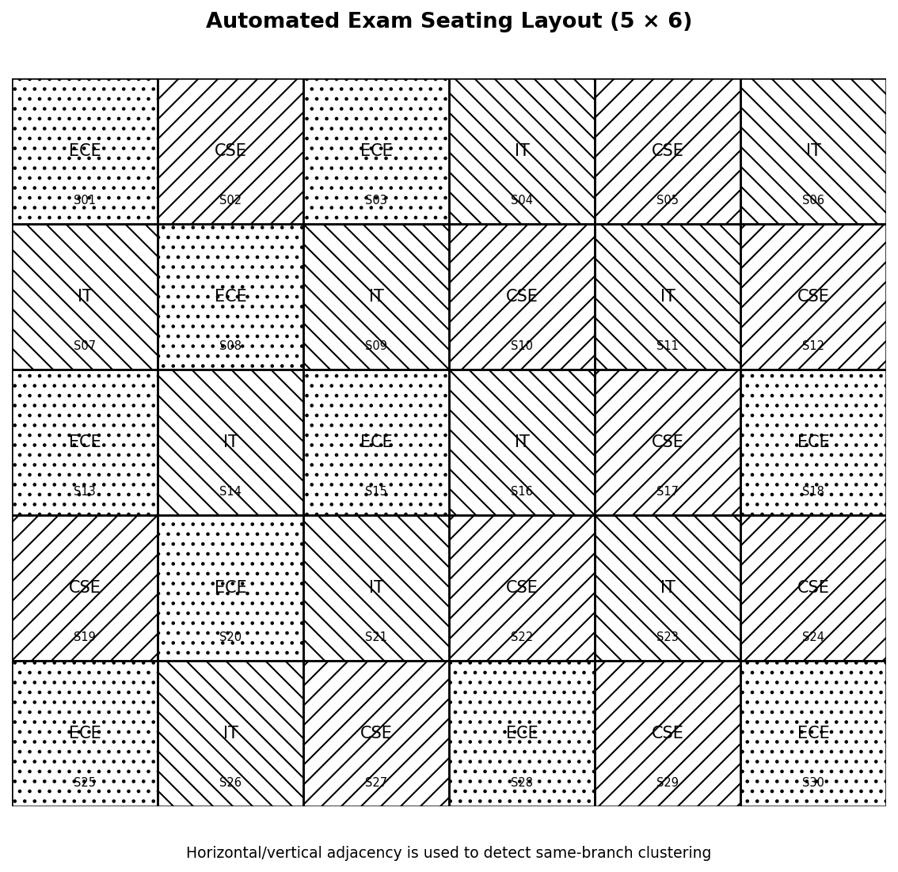
Figure 1: Automated Exam Seating Layout Showing Branch-Aware Allocation
For the sample 5 × 6 hall, 30 students are allocated across CSE, IT, and ECE. The final arrangement shown in Figure 1 contains no horizontally or vertically adjacent students from the same branch. This provides a direct visual check of the clustering objective while preserving the required 30 assignments.
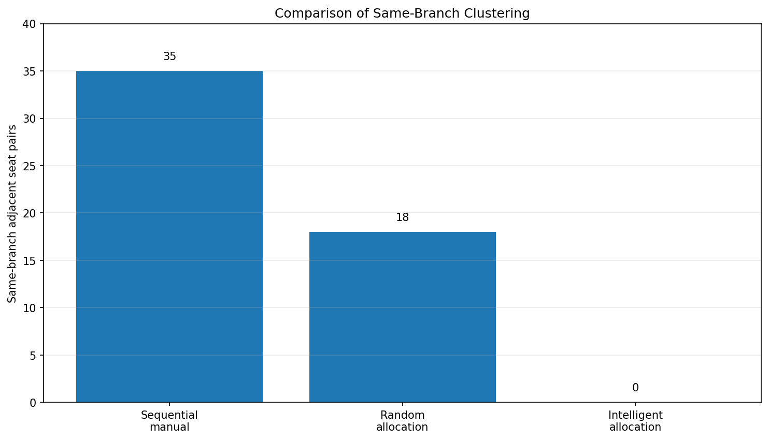
Figure 2: Comparison of Same-Branch Clustering for Baseline and Proposed Allocation
Quantity | Proposed Intelligent Allocation | Baseline / Reference
Students assigned | 30 | 30
Same-branch adjacent pairs | 0 | Sequential: 35
Normalised clustering score | 0 / 49 = 0.00 | Sequential: 35 / 49 = 71.43%
Seat uniqueness | 100% | 100%
Table 4.1: Seating Allocation Results Compared with Baseline Approaches

4.5 Data Analysis & Engineering Judgment
The sample results show a clear improvement in the defined objective. Sequential registration-order allocation creates 35 same-branch adjacent pairs out of 49 possible adjacency relationships, while a random arrangement gives 18. The proposed branch-aware allocation reaches 0 conflicts in the sample layout. The result demonstrates that the objective is measurable and that a simple local-improvement method can substantially improve the seating pattern. Because this is a controlled sample, the result should not be interpreted as a guarantee for every future dataset.

4.6 Comparison with Existing Solutions & Achievement of Objectives
Objective | Evidence | Achievement
Prepare and validate examination data | Module 1 checks student IDs, branch labels, room capacity, and seats | Fully Achieved
Maintain one-student-per-seat assignment | Final sample contains 30 unique student-seat assignments | Fully Achieved
Reduce same-branch clustering | Proposed score 0 compared with sequential baseline score 35 | Fully Achieved
Generate a readable seating chart | Figure 1 provides a room-wise seat map with branch labels | Fully Achieved
Compare with existing/simple approaches | Table 4.1 compares proposed and baseline arrangements | Fully Achieved
Examine applicability and limitations | Limitations documented in Section 4.7 | Fully Achieved

4.7 Strengths & Limitations
Strengths:
● Explicitly measures same-branch clustering instead of relying only on visual judgement.
● Preserves hard constraints such as one-student-per-seat and room capacity.
● Produces a clear seating chart and an auditable allocation summary.
Limitations:
● The sample objective considers branch adjacency but does not optimise every possible examination rule.
- Large or highly constrained datasets may require a more advanced optimisation solver.
● The reported numerical improvement is based on the sample test case and must be re-evaluated for each new dataset.

Project Planning, Roles & Budget
Milestones:
• Week 1–2 – Problem definition and literature review.
• Week 3 – Student information preparation.
• Week 4 – Hall and room modelling.
• Week 5 – Automated seat allocation.
• Week 6 – Conflict detection and validation.
• Week 7 – Report generation, testing, and comparison.
• Week 8 – Final documentation and submission.
Roles:
• Jagan G – Automated examination seat allocation system.
• Priyan A – Student information management system.
• Pushparaj G – Report generation and export system.
• Ajay Kumar – Exam hall and room management system.
• Mohan Krishna Balaji – Seat conflict detection and validation system.
Budget:
• Python and open-source libraries – ₹0.
• Personal computing resources – ₹0.
• Report printing and binding – approximately ₹500.
Milestone |  | Target Week |  | Status
Target Week |  | Status |  | Completed
Week 1–2 |  | Completed |  | Completed
Week 3 |  | Completed |  | Completed
Week 4–5 |  | Completed |  | Completed
Week 6 |  | Completed |  | Completed
Week 7–8 |  | Completed |  | Completed
Student | Actual Contribution |  |  | Actual Contribution
Jagan G | Completed as assigned |  |  | Completed
Priyan A | Completed as assigned |  |  | Completed
Pushparaj G | Completed as assigned |  |  | Completed
Ajay Kumar | MODULE 4: Exam Hall & Room Management System |  | Completed as assigned | Completed | Completed
Mohan Krishna Balaji | MODULE 5: Seat Conflict Detection & Validation System | Completed as assigned | Completed as assigned | Completed | Completed
Actual Cost |  |  | Estimated Cost |  | Actual Cost
₹0 |  |  | ₹0 |  | ₹0
₹0 |  |  | ₹0 |  | ₹0
₹500 |  |  | ₹500 |  | ₹500

CHAPTER 5
CONCLUSION, FUTURE WORK AND REFLECTION

5.1 Conclusion
This project developed an automated examination seating prototype focused on preventing same-branch clustering. By separating data preparation from intelligent allocation and validation, the system provides a structured method for converting a student list and room layout into a verifiable seating plan. In the sample 5 × 6 hall, the proposed arrangement reduced the same-branch adjacency score from 35 for sequential allocation and 18 for a random allocation to 0, while assigning all 30 students to valid seats. The outcome demonstrates the usefulness of a transparent branch-aware allocation strategy for reducing avoidable clustering.

5.2 Future Work
Future versions can incorporate subject combinations, examination-room restrictions, accessible seating, students who must or must not sit together, multiple rooms, variable row layouts, and stronger optimisation techniques. A constraint-programming or integer-programming formulation could be added for globally optimised solutions. The system could also provide printable room-wise reports, administrator authentication, encrypted data storage, audit logs, and a web interface for secure deployment.

5.3 Professional Learning & Individual Reflection
New Knowledge Acquired:
● Constraint modelling for real-world allocation problems and the separation of hard constraints from soft objectives.
● Graph-based representation of seat adjacency and the use of measurable conflict scores.
● Practical implementation of greedy allocation and local-search improvement in Python.
Engineering & Professional Skills Developed:
● Designing a data-validation workflow for student and room information.
● Implementing, testing, and debugging an allocation algorithm with measurable acceptance criteria.
● Analysing baseline results and making engineering judgements about algorithmic trade-offs.
● Coordinating modular development, documentation, testing, and report preparation.

Individual Reflection – Priyan A
The most difficult part of my work was designing the input-validation stage so that invalid student records, duplicate IDs, and insufficient room capacity could be detected before allocation. I learned that reliable automation begins with clean input data. If the project were repeated, I would add a larger automated test suite covering malformed branch labels, duplicate registrations, blocked seats, and multiple-room inputs.

Individual Reflection – Jagan G (192421039)
The most difficult part of my work was selecting an allocation strategy that reduced clustering without making the system unnecessarily complex. I implemented the branch-aware placement and local-swap idea and used the same-branch adjacency count as a measurable objective. I learned that a simple, explainable metric can make an optimisation problem easier to test and communicate. In future, I would compare the local-search approach with a constraint solver on larger datasets.

Team Reflection – Validation and Integration
The team learned that a useful engineering solution should be measurable, reproducible, and easy for its intended users to verify. The final validation compared the proposed seating arrangement against simple baselines and checked student count, seat uniqueness, room capacity, and clustering score. The next improvement would be a larger dataset study across different room shapes and branch distributions.

REFERENCES
[1] M. W. Carter, G. Laporte and S. Y. Lee, “Examination timetabling: Algorithmic strategies and applications,” Journal of the Operational Research Society, 47, 373–383, 1996.
[2] A. Schaerf, “A survey of automated timetabling,” Artificial Intelligence Review, 13, 87–127, 1999.
[3] E. K. Burke, E. Petrovic, “Recent research directions in automated timetabling,” European Journal of Operational Research, 140, 266–280, 2002.
[4] D. Abramson, “Constructing school timetables using simulated annealing: A comparison with sequential methods,” Management Science, 37, 98–113, 1991.
[5] C. H. Papadimitriou and K. Steiglitz, Combinatorial Optimization: Algorithms and Complexity. Dover Publications, 1998.
[6] D. West, Introduction to Graph Theory, 2nd ed. Prentice Hall, 2001.
[7] S. Russell and P. Norvig, Artificial Intelligence: A Modern Approach, 4th ed. Pearson, 2021.
[8] W. McKinney, Python for Data Analysis, 3rd ed. O’Reilly Media, 2022.
[9] Python Software Foundation, “Python 3 Documentation,” 2026. [Online].
[10] NumPy Developers, “NumPy Documentation,” 2026. [Online].
[11] Matplotlib Developers, “Matplotlib Documentation,” 2026. [Online].
[12] Pandas Developers, “Pandas Documentation,” 2026. [Online].

APPENDICES
Appendix A – Sample Input Data
Sample input data used for testing the automated examination seating system, including student register numbers, student names, branch labels, examination details, examination hall numbers, room capacity, and available seat numbers. The input data is used to test student information management, seat allocation, branch separation, and report generation.
Appendix B – Engineering Drawings / Schematics
Engineering drawings and system diagrams representing the automated examination seating workflow, including the system architecture, student information flow, seat allocation process, hall-wise seating arrangement, and branch-aware seat distribution. The seating layout illustrates how students are assigned to available seats while avoiding same-branch students in adjacent positions.
Appendix C – Source Code / Code Repository Information
Source code developed for the software implementation of the project, including student data management, database connectivity, examination seat allocation, branch-based constraint checking, seat assignment, report generation, search functionality, and PDF/Excel export. The implementation supports the complete workflow from student data input to final seating report generation.
Appendix D – Datasheets
Not applicable – The project is completely software-based and does not require physical electronic components, hardware devices, sensors, or equipment datasheets.
Appendix E – Experimental / Raw Data
Testing data and experimental results used to evaluate the seating allocation system, including student allocation records, hall-wise seat assignments, branch separation results, duplicate-seat validation, missing-seat checks, and generated seating reports. The results are used to verify the correctness and reliability of the automated allocation and reporting process.
Appendix F – Ethics / Institutional Approval
Not applicable – The prototype uses controlled academic student data for project demonstration and testing. The system does not involve biometric processing, medical information, or other physical data collection. Appropriate data protection should be considered if the system is deployed with real institutional student information.
Appendix G – Project Meeting / Progress Records
Records related to team discussions, module planning, development activities, module integration, testing, debugging, report generation, and project milestone tracking. These records document the progress of the automated examination seating system from initial design through implementation and testing.
Appendix H – User / Industry Feedback
Not applicable for the current academic prototype. The system has been developed as an academic project. In future deployment, feedback can be collected from examination-cell staff, faculty members, and administrators to improve seating allocation, report generation, search functionality, and overall usability.
Appendix I – Publications / Patents / Competitions / Product Outcomes
None at the time of submission. The project has been developed as an academic capstone project and has not been published, patented, commercialized, or submitted to a competition at the time of project submission.
Appendix J – Individual Contribution Evidence
Supporting evidence related to the individual contribution made to Module 3: Report Generation and Export System. The contribution includes developing the hall-wise seating report, displaying student seat and hall details, creating printable seating charts, implementing PDF/Excel export functionality, and providing quick search for student seat allocation. These records correspond to the Individual Contribution Statement and demonstrate ownership of the assigned module.
.

CAPSTONE PROJECT OUTCOME MAPPING SHEET

To be completed by the department/faculty assessor.
Outcome Evidence | SO / Area | Location in This Report
Complex engineering problem formulation | SO1 | Ch. 1, Ch. 2
Engineering design under constraints | SO2 | Ch. 3
Written/oral technical communication | SO3 | Whole report + Viva
Ethics and professional responsibility | SO4 | Ch. 3 (3.7)
Teamwork and leadership | SO5 | Ch. 4 (4.8)
Experimentation, analysis, engineering judgment | SO6 | Ch. 4 (4.3–4.6)
Independent acquisition of new knowledge | SO7 | Ch. 5 (5.3)
Standards / institutional rules | SO2 | Ch. 3 (3.2)
Sustainability and societal/environmental impact | SO2/SO4 | Ch. 3 (3.7)
Risk assessment and mitigation | SO2/SO4 | Ch. 3 (3.7)
Security considerations | Relevant SO | Ch. 3 (3.7)
Integrated/system-level engineering | SO1/SO2 | Ch. 3 (3.5)
Project planning and management | SO5 | Ch. 4 (4.8)
Individual contribution | SO1–SO7 | Contribution Statement + Ch. 4 (4.8)

